**Steps for pasting the lbpcascade_frontalface.xml file in the required folder**

Step 1: Copy the file from the main directory  
  
Step2: Go to **C drive**  
  
Step3: Select and turn on the hidden files button. Click on, **View 🡪 Show 🡪 Hidden Items**

Refer the image below, for step 3.

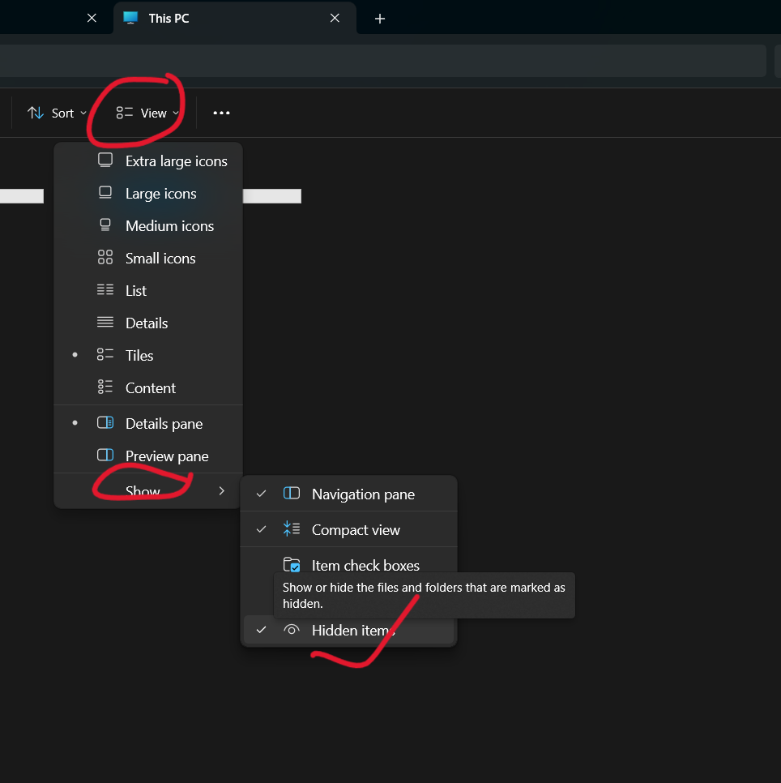

Step 4: In the C drive, select the **Users** folder, then in the Users folder, select the folder that has your **name** or the name that is shown when your PC / Laptop is starting. If users name is Alex, then select that folder.  
  
Step 5: After accessing the folder with your name on in, then in that folder, open the **App Data folder**.

Step 6: Open the **App Data folder**, in that open the folder called **Local**.

Step 7: Open the **Local** folder and find the **Programs** folder and open it

Step 8: After opening the **Programs** folder, in that folder find the folder called **Python** and open it.

Step 9: After opening the **Python** folder, select the Python folder of your **python version**. If your Python version is 3.12.1, then your folder name will be **Python312**.

Step 10: After opening the **Python version** folder, **Lib** folder in it and open it.

Step 11: In the **Lib** folder, look for **site-packages** folder and open it.

Step 12: In the folder **site-packages**, search for the **cv2** folder and open it.

Step 13: In the **cv2** folder, open the folder called **data** folder and paste our xml file there.

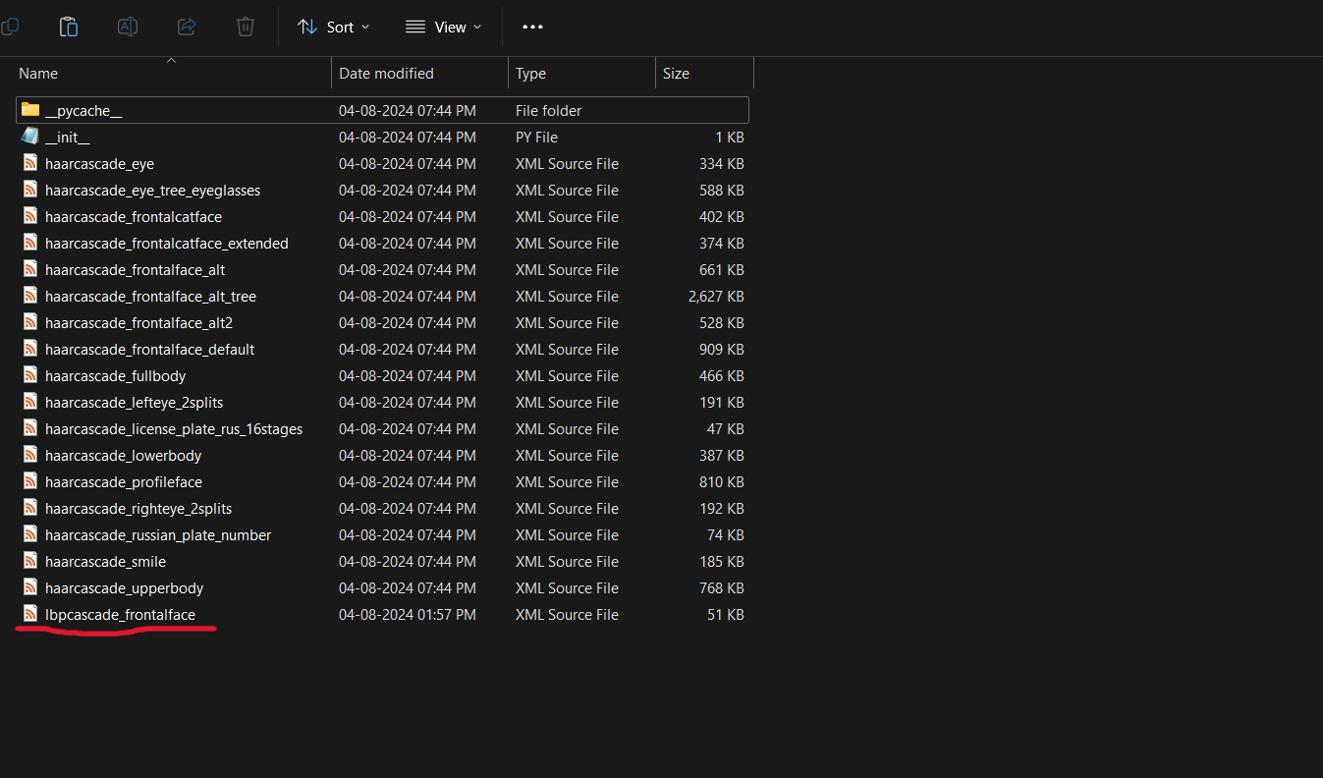

The file history will look something like this –

**C:\Users\your_name\AppData\Local\Programs\Python\Python312\Lib\site-packages\cv2\data**